# CS 255 System Design Document

## UML Diagrams

### UML Use Case Diagram

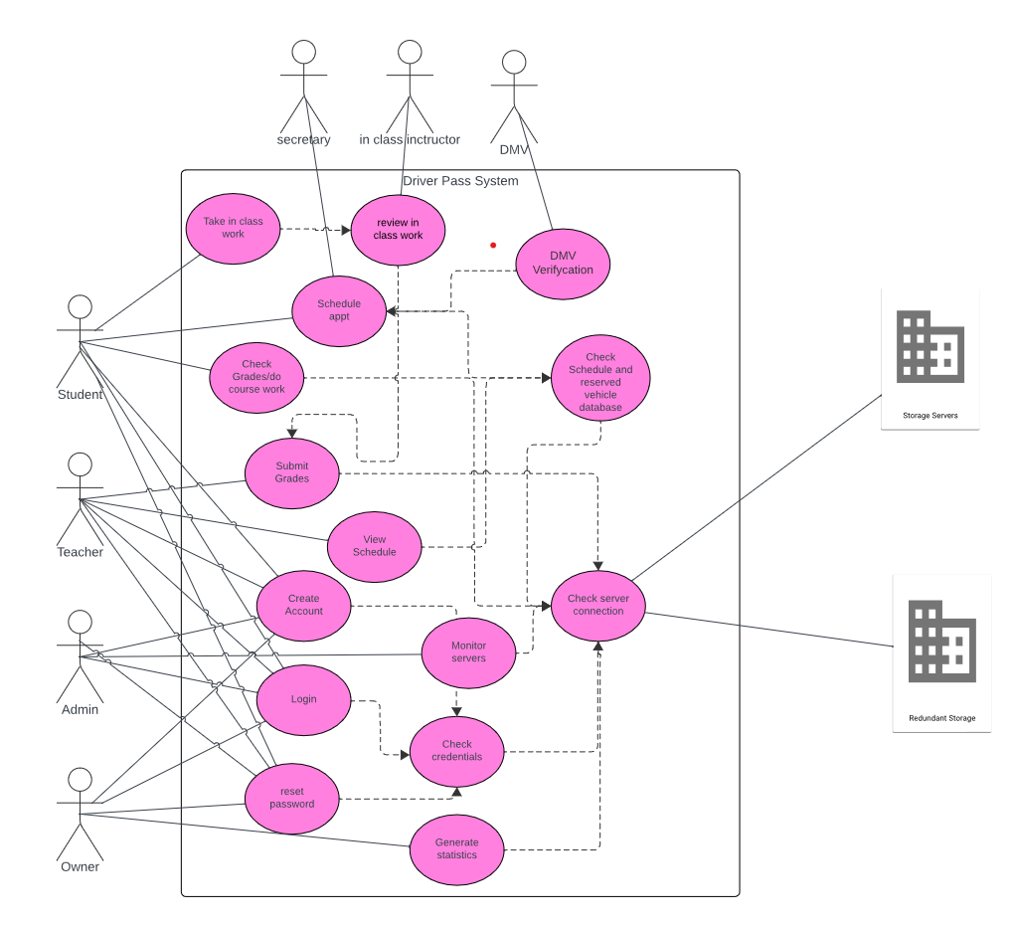

### UML Activity Diagrams

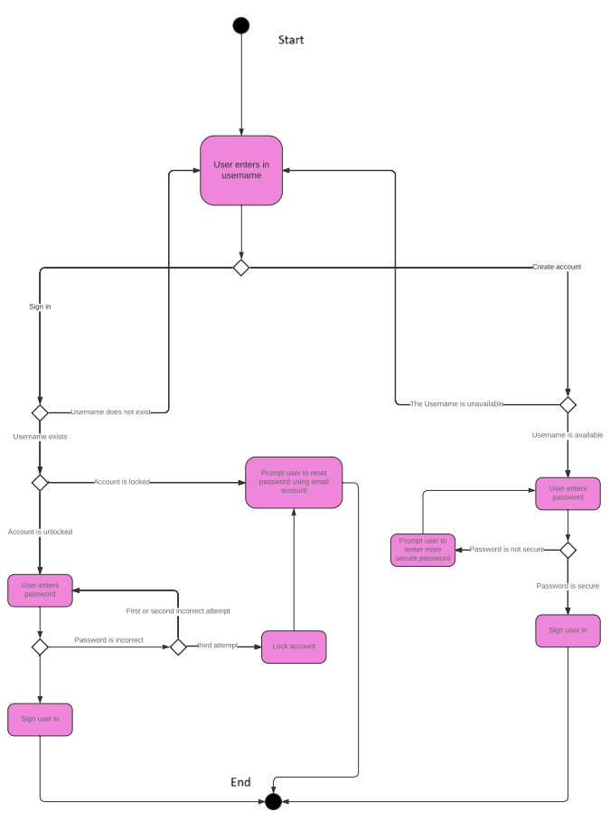

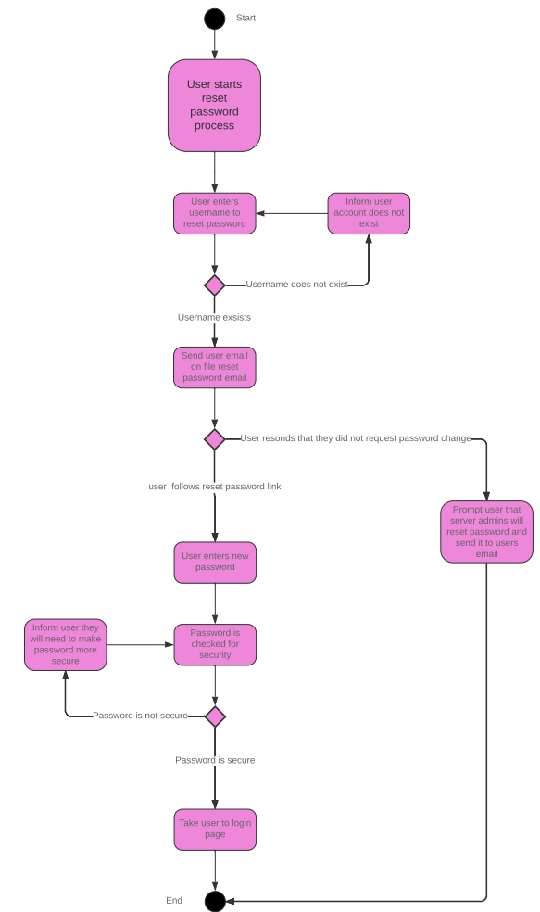

### UML Sequence Diagram

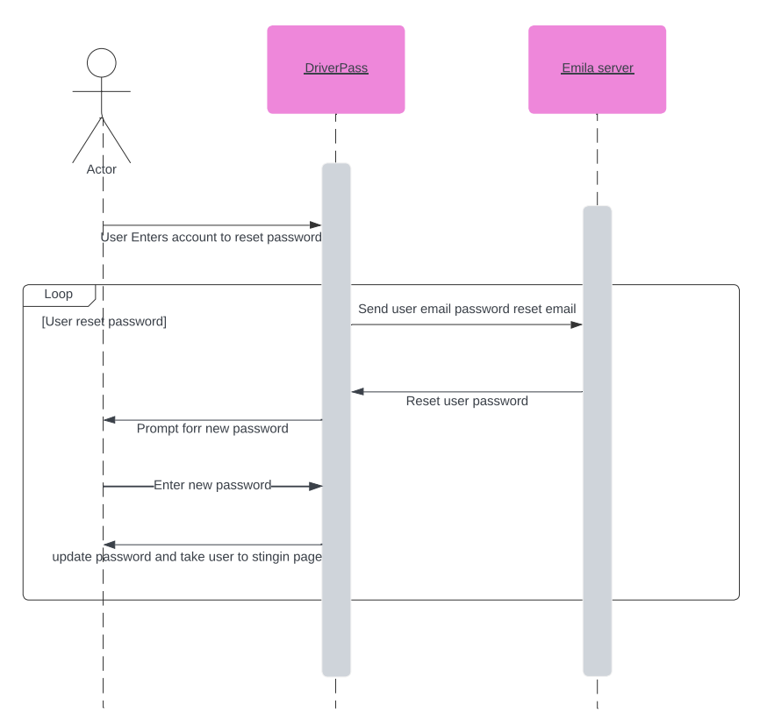

### UML Class Diagram

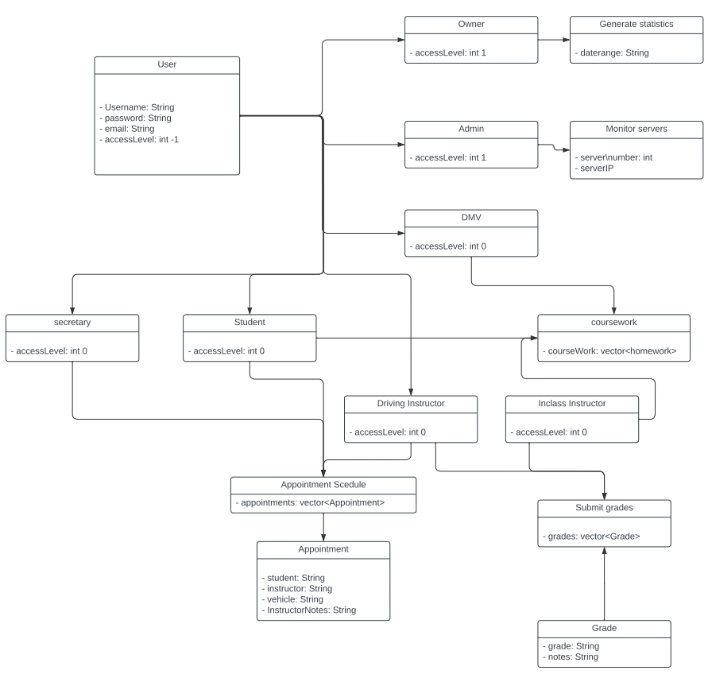

## Technical Requirements

Hardware Requirements:

* Multiple servers with server redundancy to ensure that there is no downtime for a user.
* Dedicated encrypted storage for user data so that customer user data is protected.
* Server firewall to protect servers from attackers.

Software Requirements:

* Linux server hosts the web server so that any device will be able to connect.
* Database management for storing and updating databases.
* Antivirus software to protect against unwanted attacks on the server.

Tools

* Implement cloud services for storage and redundancies so that local power outages will not take the service down.
* include a load balancer for servers and databases to not overwhelm the servers so that every user will be able to connect and have the same speed in service.
* Have redundancies in every region data center so that west coast and east coast users will still be able to have the same access to data.